Basic Shell Scripts:

Output to screen

#!/bin/bash
# Simple output script

echo "Hello World"

vi outputscreen.bash

write a script as below

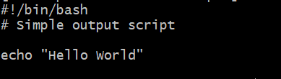

Give permission to script file chmod 755 outputscreen.bash

Defining Tasks

#!/bin/bash
# Define small tasks

whoami
echo
pwd
echo
hostname
echo
ls -ltr
echo

create a file vi definingtask.bash

write a above script

chmod 755 definingtask.bash

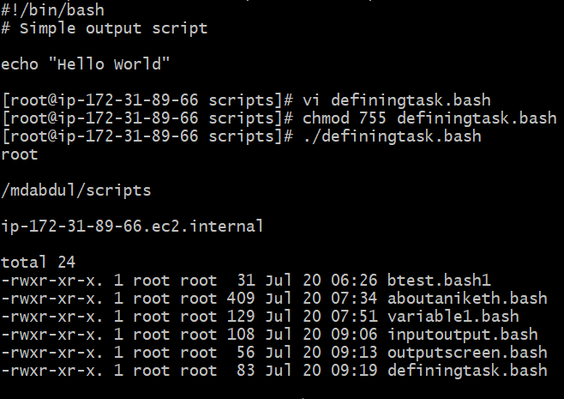

Defining variables

#!/bin/bash
# Example of defining variables

a=Imran
b=Afzal
c=’Linux class’

echo "My first name is $a"
echo "My surname is $b"
echo ‘My surname is $c’

create a file vi definingvariables.bash

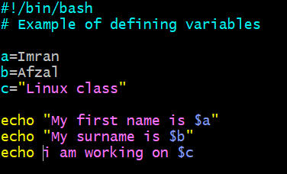

write a above script (the above script in task corrected by us)

chmod 755 definingvariables.bash

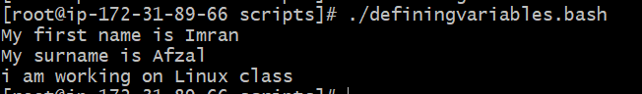

Read Input

#!/bin/bash
# Read user input

echo "What is your first name?"
read a
echo

echo "What is your last name?"
read b
echo

echo Hello $a $b

create a file vi readinput.bash

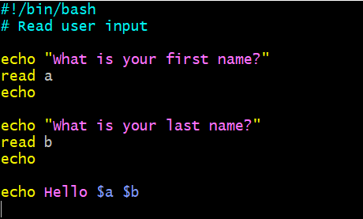

write a above script

chmod 755 readinput.bash

execute the script file

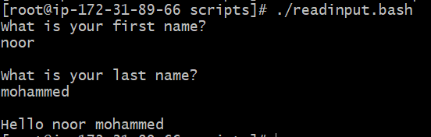

Scripts to run commands within

#!/bin/bash
# Script to run commands within

clear
echo "Hello `whoami`"
echo
echo "Today is `date`"
echo
echo "Number of user login: `who | wc -l `"
echo
- create a file vi runcommands.bash

- write a above script

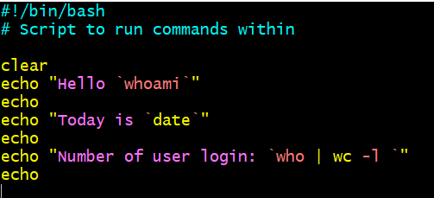

- chmod 755 runcommands.bash

- execute the script file

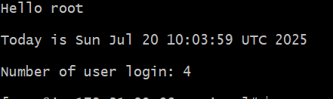

Here whoami, who, wc -1 are commands
On every command backtick ` should put at start and end.
To know the number users the command is who | wc –l
Just for knowledge what is the command to now number usernames?

Read input and perform a task

#!/bin/bash
# This script will rename a file

echo Enter the file name to be renamed
read oldfilename

echo Enter the new file name
read newfilename

mv $oldfilename $newfilename
echo The file has been renamed as $newfilename
- create a file vi runcommands.bash

- write a above script

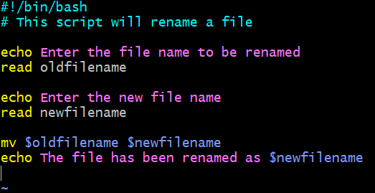

- chmod 755 runcommands.bash

- execute the script file

